BI
Mini Project
Statistical Analysis of Campus Recruitments

Document Control
Table of Contents
Reference No:
Security Classification: | IGATE Internal
Issue Date:
Author(s): | Name |  | Title
Author(s): | Vandana Mistry |  | Deputy Manager
Reviewer(s): | Name |  | Title
Issuer(s): | Name |  | Title
Issuer(s): | Vandana Mistry |  | Deputy Manager
Issuer Signature(s):
Distribution: | Name |  | Title
Distribution: | IGATE Corporate University |  | All Designations in IGATE Corporate University
Document History: | Date | Revision | Change
Document History: | Oct 2014 | 1.0 | Document creation
1 Introduction 4
1.1 Setup Checklist for Mini Project 4
1.2 Instructions 4
2 Problem Statement 5
2.1 Objective 5
2.2 Abstract of the project 5
2.3 Technology used: 5
3 Implementation in BI LOT 6
3.1 Summary of the functionality to be built: 6
3.2 Guidelines on the functionality to be built: 7
4 Evaluation and assessment parameters 11

Introduction

This document outlines a mini project for the BI LOT. The project is to develop Analysis & Reporting System of Campus Recruitments
This document contains the work flow of the system and gives guidelines on how to build the functionality gradually in each of the course modules of the BI LOT.

Setup Checklist for Mini Project
Minimum System Requirements
- Intel Pentium 90 or higher (P166 recommended)
- Microsoft Windows 95, 98, or NT 4.0, 2k, XP, Windows 2007.
- Memory: 32MB of RAM (64MB or more recommended)
- Internet Explorer 6.0 or higher
- Oracle 9i client and access to oracle 9i server or SQL Server Client and access to SQL Server
- ETL Tool
- Reporting tool

Instructions
- The code modules in the mini project should follow all the coding standards.
- Create a directory by your name in drive <drive>. In this directory, create a subdirectory MiniProject. Store your Project here.
- You can refer to your course material.
- You may also look up the help provided in the BI docs and documentation provided with Informatica and Business Objects.

Problem Statement

Objective
Development of a Analysis & Reporting System of Bank Account Details

Abstract of the project
The project is to develop Analysis & Reporting System of Bank Account Details of the IT Employees

Technology used:
- Oracle 9i (Database)
- Informatica power center 9.5.1 (ETL Tool):-
- Reporting Tool

Implementation in BI LOT

Summary of the functionality to be built:
The participants need to develop the Analysis & Reporting System of Bank Account Details by building the functionality incrementally in each of the course modules of BI LOT.

Sr. No | Course | Duration | No. of Saturdays | Functionality to be built
Sr. No | Course | (in PDs) | No. of Saturdays | Functionality to be built
1. | Programming Foundation using Pseudo code | 5 | 2
3. | Oracle | 7 | 2
4. | Unix | 4 | 2
5. | Oracle Test | 1 | 2
6. | Informatica 9.5.1 | 6 | 1 | Perform ETL to generate the fact tables and Dimension tables.
6. | Informatica 9.5.1 Test | 1 | 1
7 | OBIEE 11g | 4 | 1 | Create a Universe in BO and create Reports
8 | OBIEE 11g Test | 1 | 1 | Create a Universe in BO and create Reports
9 | SQL Server | 2 | 1 | Create Reports in SSRS
10 | SSRS | 4 | 1 | Create Reports in SSRS

Guidelines on the functionality to be built:

Project flow

Heterogeneous Sources i.e. operational data (Flat files)
EXTRACT
TRANSFORM
LOAD
Data warehouse (Oracle)
Reports Based On Universe
UNIVERSE
(Informatica)
(BO IDT)
(BO XI Rich WebI/WebI)

The participants are expected to create a star/snowflake schema model based on the OLTP source files shared with them.
The source files are
  - Source file 1
    - Date
    - College Name
    - Company Name
    - Package
    - Students Selected
    - Students Participated
    - Criteria
  - Source file 2
    - Date
    - College Name
    - Survey Name
    - Number of Indian Students
    - Number of Foreign Students
    - Fees
    - Rank

The survey is conducted annually and the information in the above fact table is at the level of Year.

The OLAP schema diagram is as shown below
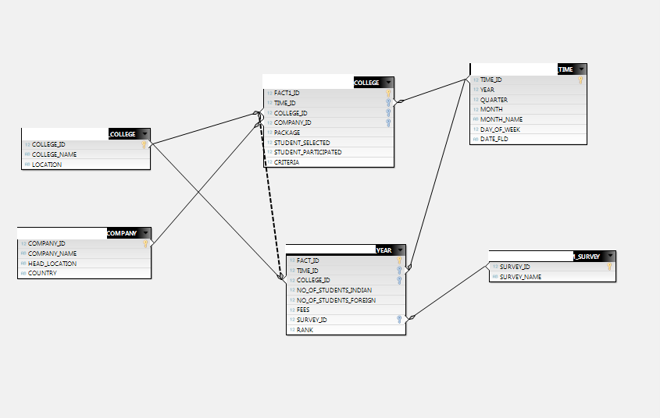
The Dimension tables to be created and populated are
  - College
    - College ID
    - College Name
    - College Location
  - Company
    - Company ID
    - Company Name
    - Head office Location
    - Country

  - Survey
    - Survey ID
    - Survey Name
  - Time
    - Time ID
    - Year
    - Quarter
    - Month
    - Month Name
    - Day of Week
    - Date

The Fact Tables to be created and populated are
- Fact College Details
    - Fact ID
    - Time ID
    - College ID
    - Company ID
    - Package(In lakhs)
    - Students Selected
    - Students Participated
    - Criteria

- Fact Survey Details
    - Fact ID
    - Time ID
    - College ID
    - Survey ID
    - Number of Indian Students
    - Number of Foreign Students
    - Fees
    - Rank

The survey is conducted annually and the information in the above fact table is at the level of Year.

Note: The datatype/length for the Dimension/Fact table attribues can be changed as required. Additional fields can be added, if required.

Sample Reports

- College Ranking
- Year wise ranking of the college
- Number of Colleges Visted Per Quarter
- Student Placement Percentage Per Year
- Year Wise Total number of Students Selected
- Year Wise Quarter Wise Placement
- Top rank colleges for a particular company
- Total amount spent by a company per year
- Companies with criteria and their packages
- State wise placement

Referred to the shared source files.

Sample Reports

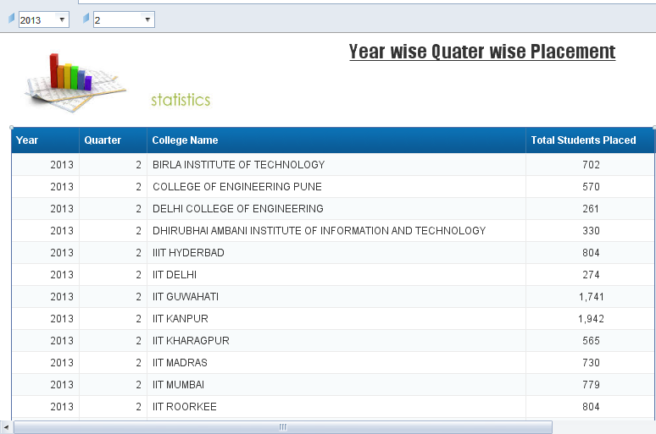

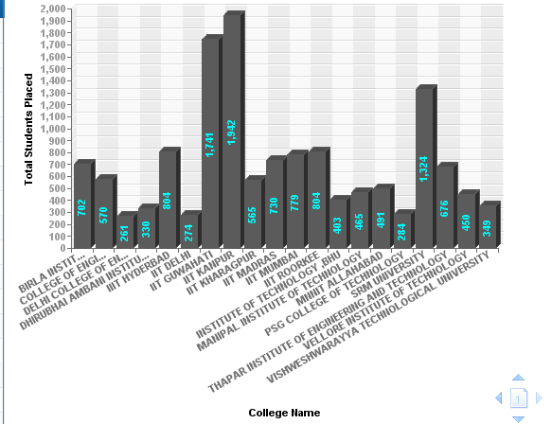

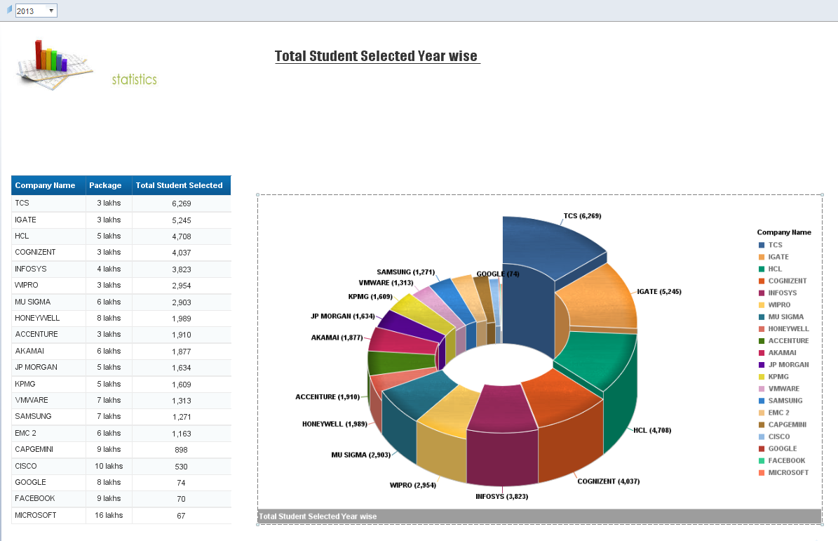
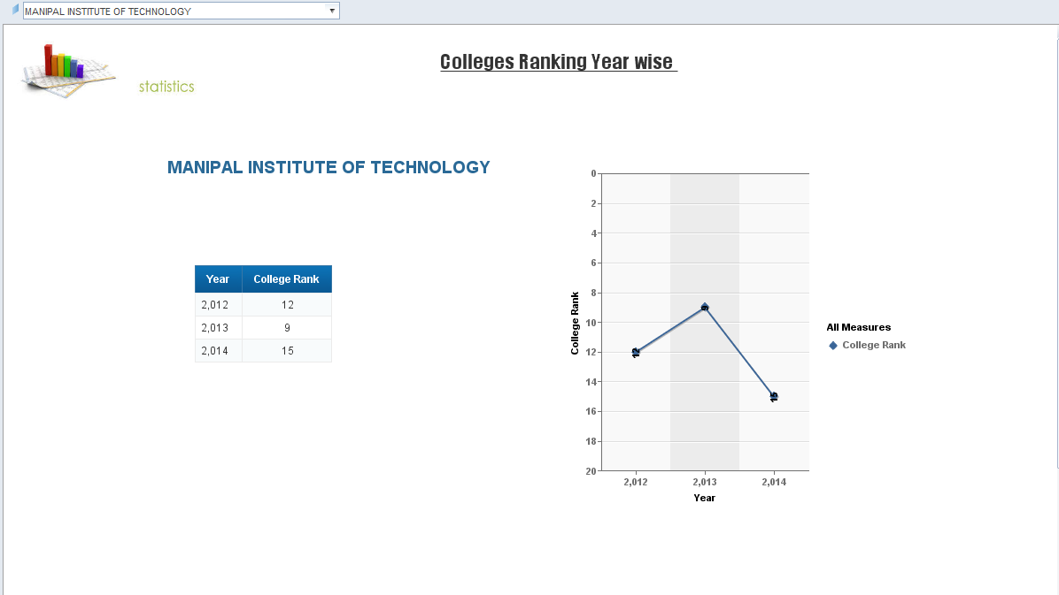

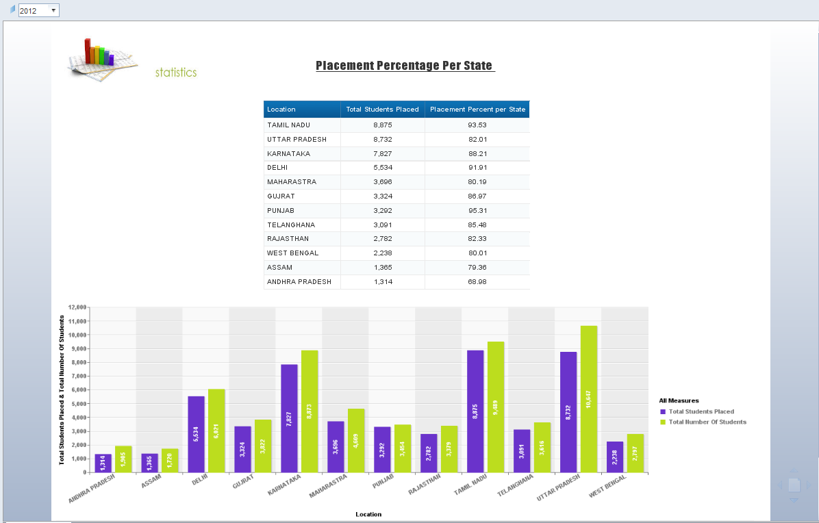

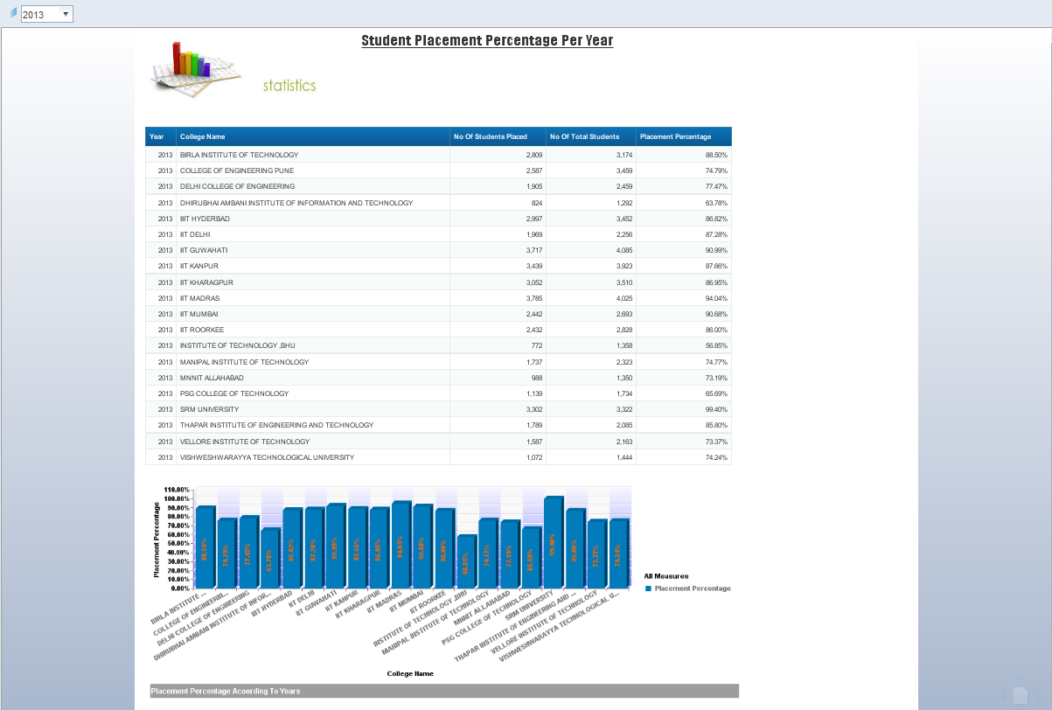

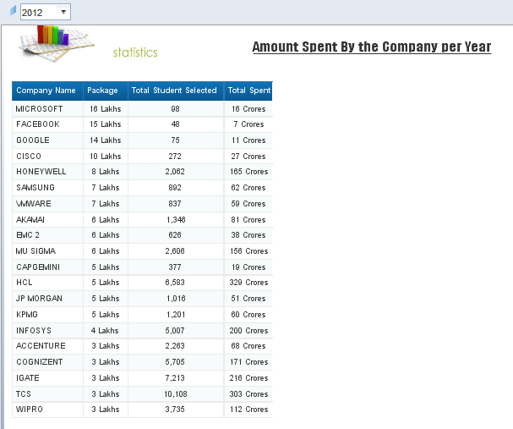
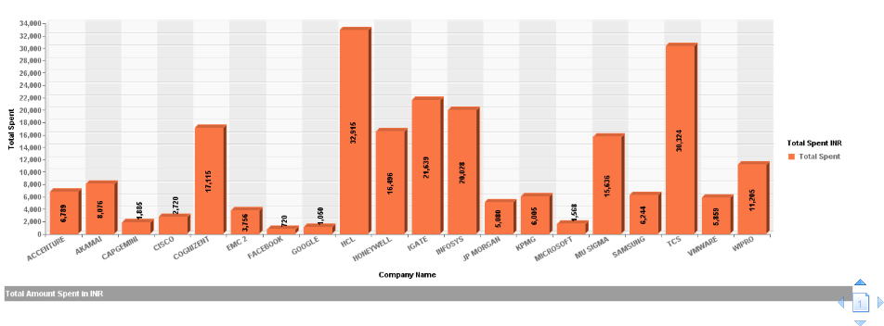

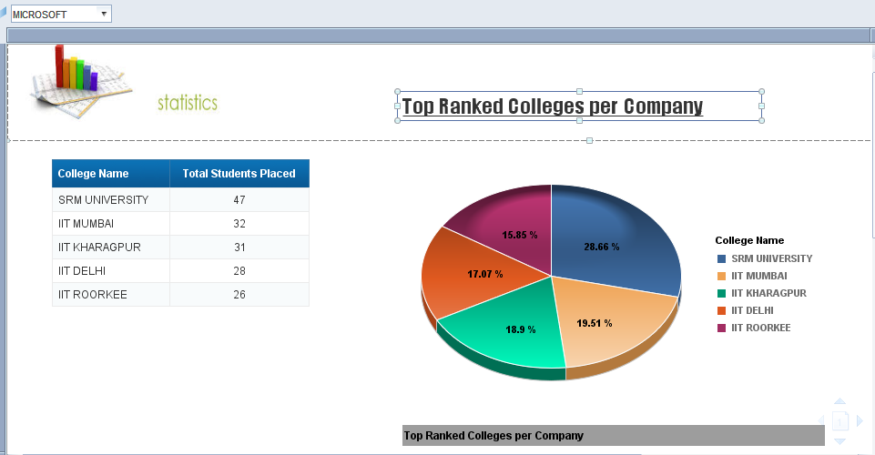
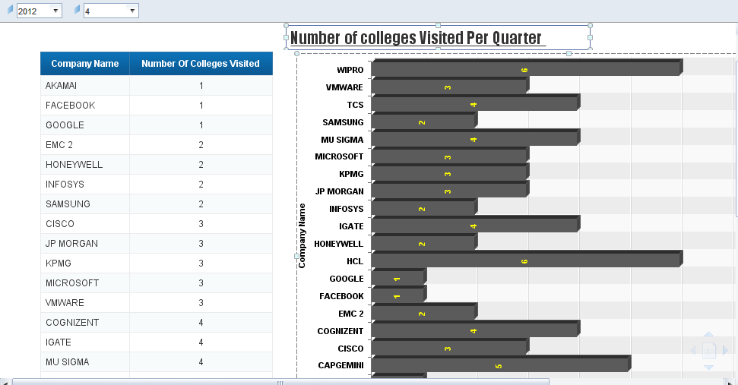
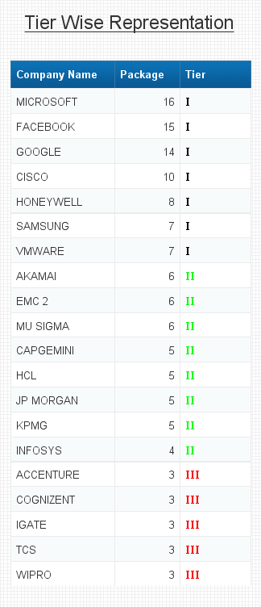

Evaluation and assessment parameters
This mini project will be done in groups of five or six. Each group will identify a Team Lead who will decide which team member will code for which functionality. This project shall be evaluated in two phases. Evaluation will be done using online presentation mode, where each group will present their respective modules.

Evaluation Parameters (100 Marks)
- ETL Scripts and DW design (25)
The extent to which the ETL was performed, the transformations used
Deliverables in terms of time lines
- Sematica Layer in Reporting tool (35)
The way the universe was designed with appropriate classes and objects, conditions created
- Deliverables(Reports) (40)
Presentation of reports.

